SRM INSTITUTE OF SCIENCE AND TECHNOLOGY
FACULTY OF SCIENCE AND HUMANITIES
DEPARTMENT OF COMPUTER APPLICATIONS

PRACTICAL RECORD NOTE
STUDENT NAME | :
REGISTER NUMBER | : | RA__________________
CLASS | : | MCA Section: A
YEAR & SEMESTER | : | I YEAR & II SEMESTER
SUBJECT CODE | : | PCA20S02J
SUBJECT TITLE | : | DATA ANALYSIS USING R

APRIL 2024

SRM INSTITUTE OF SCIENCE AND TECHNOLOGY
FACULTY OF SCIENCE AND HUMANITIES
DEPARTMENT OF COMPUTER APPLICATIONS
SRM Nagar, Kattankulathur – 603 203
CERTIFICATE

Certified to be the bonafide record of practical work done by NAME Register No. _________________________ of MCA Degree course for PCA20S02J – DATA ANALYSIS USING R in the Computer lab in SRM Institute of Science and Technology during the academic year 2023-2024.

Staff In-charge Head of the Department

Submitted for Semester Practical Examination held on __________________.

Internal Examiner External Examiner

INDEX

Sl.No. | Date | Content | Page No. | Staff Sign
1. | 12.12.2023 | Installation of R and R-Studio | 1-4
2. | 21.12.2023 | Working with R Packages | 5-8
3. | 03.01.2024 | Built-in Functions in R | 9-14
4. | 12.01.2024 | Control Statements | 15-16
5. | 22.01.2024 | Looping Structures | 17-18
6. | 06.02.2024 | Factorial of a Given Number | 19-20
7. | 13.02.2024 | Fibonacci Series Generation | 21-22
8. | 21.02.2024 | Check the Given Number is Prime or not | 23-24
9. | 27.02.2024 | Implementation of Decision Tree Algorithm using Titanic dataset | 25-28
10. | 05.03.2024 | Implementation of Titanic Survival Prediction using Naive Bayes Algorithm | 29-31
11. | 07.03.2024 | Implementation of K Nearest Neighbor using Iris dataset | 32-35
12. | 19.03.2024 | Implementation of Random Forest Algorithm using Iris dataset | 36-38
13. | 26.03.2024 | Implementation of K Means Clustering | 39-44
14. | 28.03.2024 | Data Visualization in R | 45-50

Ex. No:1 | Installation of R and R-Studio
Date: 12.12.2023 | Installation of R and R-Studio

INSTALLATION OF R

AIM

To install R and R-Studio

PROCEDURE

Step 1: Go to CRAN R project website - https://cran.r-project.org/
Step 2: Click on the Download R for Windows link.
Step 3: Click on the base subdirectory link or install R for the first time link.
Step 4: Click Download R 4.2.1 for Windows and save the executable .exe file.
Step 5: Run the .exe file and follow the installation instructions.
Step 6: Select the desired language and then click Next.
Step 7: Read the license agreement and click Next.
Step 8: Select the components you wish to install. Click Next.
Step 9: Browse the folder/path you wish to install R into and then confirm by clicking Next.
Step 10: Select additional tasks like creating desktop shortcuts etc. then click Next.
Step 11: Wait for the installation process to complete.
Step 12: Click on Finish to complete the installation.

OUTPUT

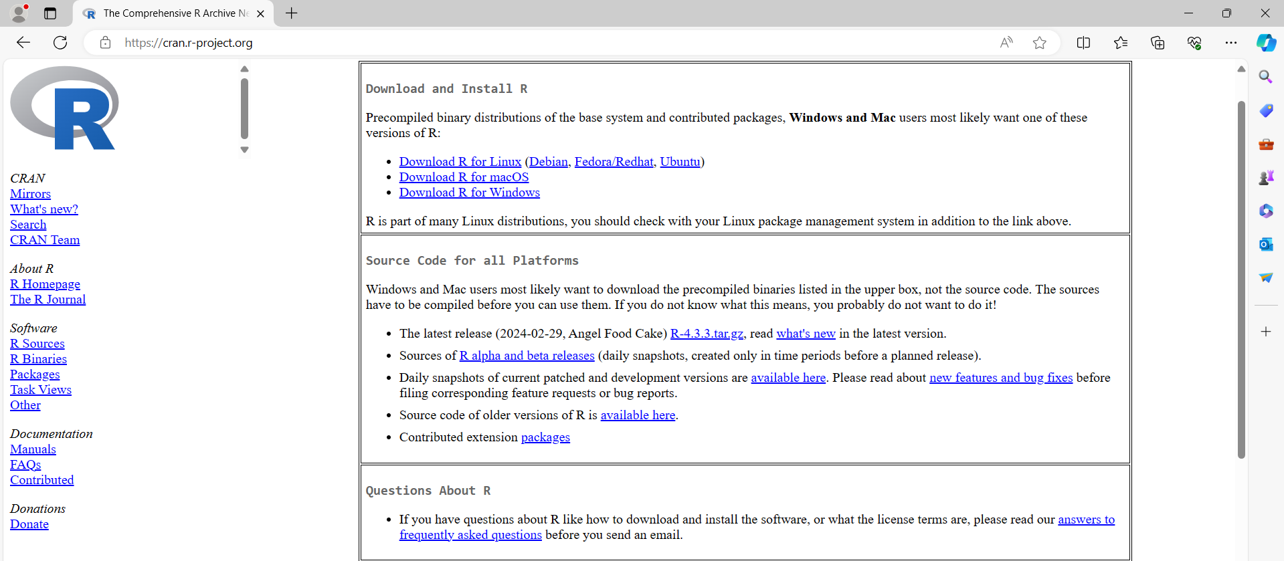

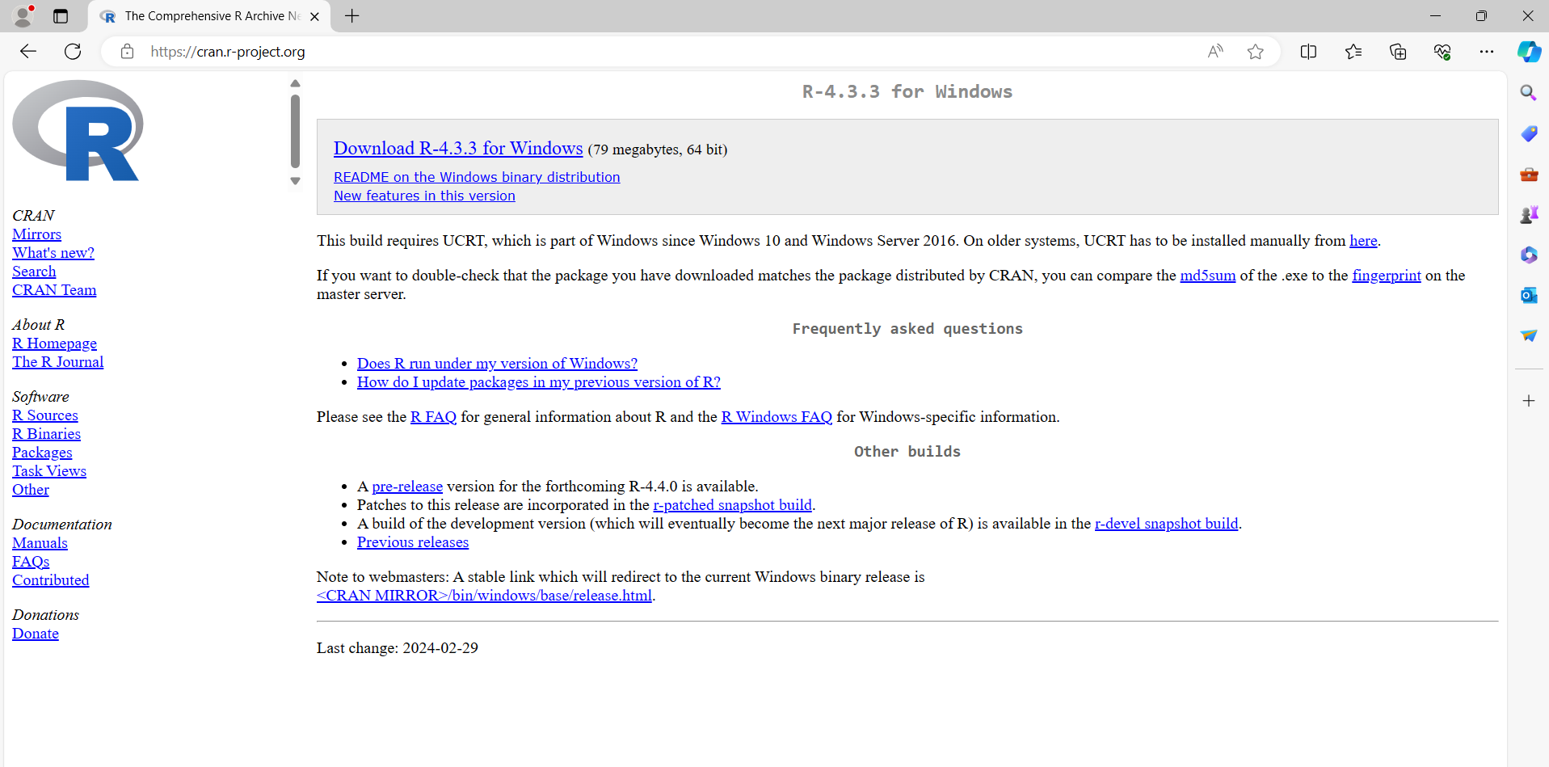

INSTALLATION OF R-STUDIO

PROCEDURE

Step 1: With R-base installed, let’s move on to installing R-Studio. To begin, go to download RStudio - https://posit.co/downloads and click on the download button for R-Studio desktop.
Step 2: Click on the link for the windows version of R-Studio and save the .exe file.
Step 3: Run the .exe and follow the installation instructions.
Step 4: Click Next on the welcome window.
Step 5: Enter/browse the path to the installation folder and click Next to proceed.
Step 6: Select the folder for the start menu shortcut and then click Next.
Step 7: Wait for the installation process to complete.
Step 8: Click on Finish to complete the installation.

OUTPUT



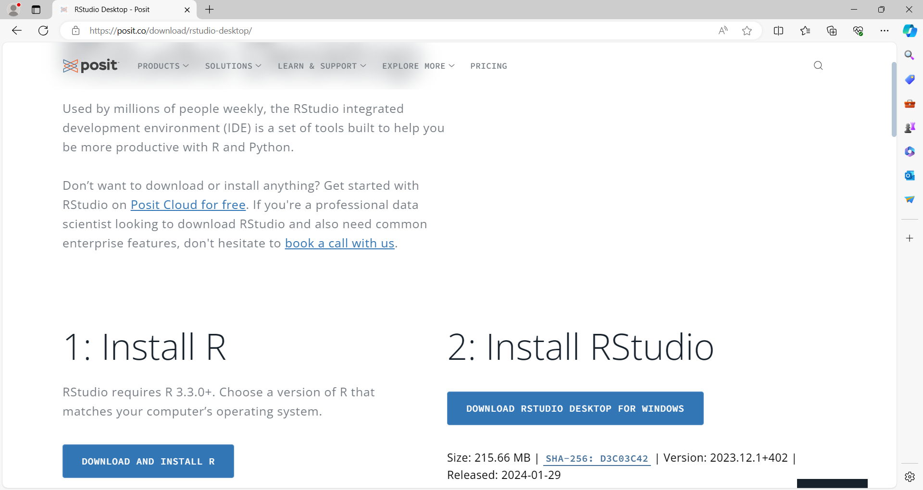

Ex. No:2 | Working with R Packages
Date: 21.12.2023 | Working with R Packages

AIM

To install, load and work with packages

PACKAGES

A package is basically just a big collection of functions, data sets and other R objects that are all grouped together under a common name. A package must be installed before it can be loaded. A package must be loaded before it can be used.

Install R Packages from CRAN
install.packages ( ) - This function is used to install a required package in the R programming language.
Example : To install ggplot2 package
install.packages(“ggplot2”)

Uninstall R Packages
remove.packages ( ) - This function is used to uninstall apackage in the R programming language.
Example : To uninstall ggplot2 package
remove.packages(“ggplot2”)

Loading of R Packages
library ( ) - It is used to load and list all the packages in the R Programming language.
Example : To load ggplot2 package
library ( ggplot2 )
To list all the packages installed
library ( )

Updating R Packages
old.packages ( ) - It is used to check which packages need an update in R.
Example : To check an update
old.packages( )

update.packages ( ) - It is used to update all the packages in R

Example : To update Packages
update.packages( )

Listing the Packages that are Installed
install.packages ( ) - It is used to list out all packages which are installed in computer
Example : To list out installed packages
installed.packages( )

Get help pages about Packages
Help ( ) and ( ? )- They provide access to the documentation pages for R functions, data sets, and other objects, both for packages in the standard R distribution and for contributed packages.

Example : To get more description about ggplot2
help(“ggplot2”) and ?ggplot2
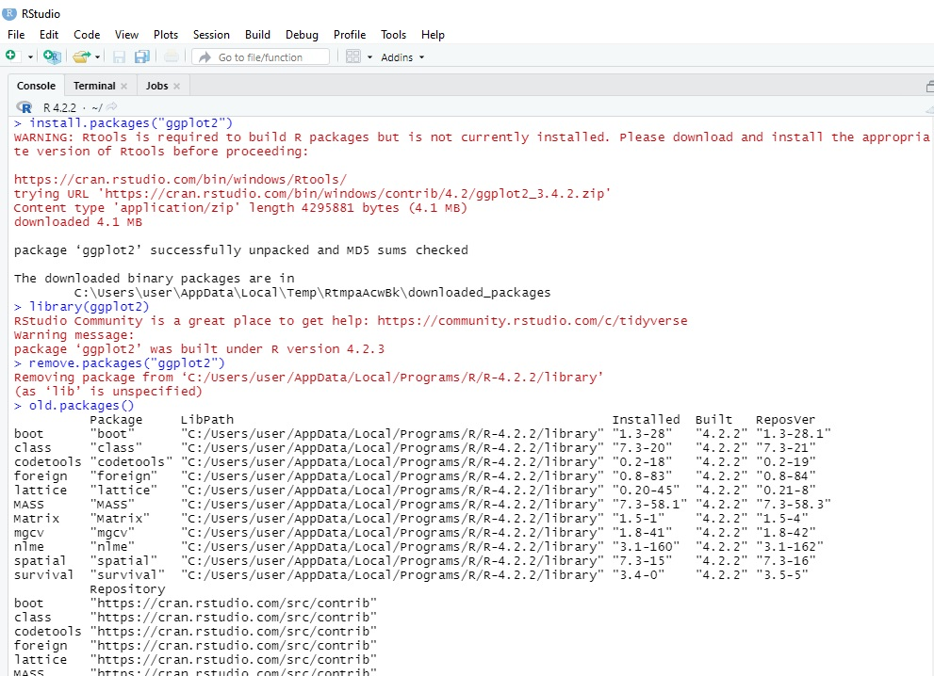
OUTPUT

Ex. No:3 | Built-in Functions in R
Date:03.01.2024 | Built-in Functions in R

AIM
To show the working of built-in function.

BUILT - IN FUNCTIONS

Functions | Description
sum() | Returns the sum of all the input vector.
prod() | Returns the multiplication result of all the input vector.
max() | Returns the maximum value of input vector.
min() | Returns the minimum value of input vector.
unique() | Returns the unique value.
sort() | Returns sorted value from input vector.
rev() | Returns reversed order of input vector.
rbind() | Combines vector and matrix row-wise.
cbind() | Combines vector and matrix column-wise.
setdiff() | Returns differences between two vectors.
cumsum() | Returns the cumulative sum of two vector.
abs() | Returns the absolute value of input vector.
sqrt() | Returns the square root of input vector.
ceiling() | Returns the smallest integer which is larger than or equal to input vector.
floor() | Returns the largest integer, which is smaller than or equal to input vector.
trunc() | Returns the truncate value of input vector.
round() | Returns round value of input vector.
cos(), sin(), tan() | Returns cos(), sin(), tan() value of input vector.
log() | Returns natural logarithm of input vector.
log10() | Returns common logarithm of input vector.
exp() | Returns exponent of input vector.

1. Create a Vector ‘v’ with the values 1,5,8,10,4,5,3,9,8,10,12 and do the
following
a. Find Sum, Mean and Product of the Vector
Solution
v =c(1,5,8,10,4,5,3,9,8,10,12)
sum(v)
mean(v)
prod(v)
b. Find the minimum and the maximum of the Vector.
Solution
min(v)
max(v)
c. Sort the Vector in ascending and descending order.
Solution
sort(v)
sort(v,decreasing=TRUE)
d. List the distinct values in the vector
Solution
unique(v)
e. Reverse the order of the vector.
Solution
rev(v)
f. Find the length and the dimension of the vector.
Solution
length(v)
dim(v)

OUTPUT

2. Create two vectors as below:
A = 0,2,4,15
B = 3,12,4,11
a. Combines these two vectors by column wise and row wise.
Solution
A = c(0,2,4,15)
B = c(3,12,4,11)
rbind(A,B)
Cbind(A,B)

b. Find the elements of ‘A’ vector that are not in ‘B’ vector.
Solution
Setdiff(A,B)

OUTPUT

3. Your cell phone bill varies from month to month.
46 33 39 37 46 30 48 32 49 35 30 48
a. Represent the above information in a vector ‘bill’
Solution
Bill = c(46,33,39,37,46,30,48,32,49,35,30,48)
b. Find the total amount you spent this year on the cell phone
Solution
sum(Bill)
c. Display the smallest amount you spent in a month
Solution
min(Bill)

d. Display the largest amount you spent in a month
Solution
max(Bill)
e. How many months was the amount greater than $40
Solution
sum(Bill>40)

OUTPUT

4. A survey asks people if they smoke or not. The data is
yes, no, no, yes, yes
a. Represent the above information in a vector
Solution
S=c(“yes”,”no”,”no”,”yes”,”yes”)
b. Display frequency table for above information
Solution
A =table(S)
df1 = as.data.frame(A)

OUTPUT

Ex. No:4 | Control Statements
Date: 12.01.2024 | Control Statements

- Finding biggest among three numbers using if else

AIM
Find and print the greatest among three numbers.
PROCEDURE
Step 1: Take three numbers x, y, and z as input from the user.
Step 2: Compare if x is greater than y and x is greater than z.
Step 3: Print the greatest number is x.
Step 4: Else if y is greater than z, print the greatest number is y.
Step 5: If neither condition holds, then print the greatest number is z.
Step 6: End of the program.

CODE

x<-as.integer(readline(“Enter first number:”))
Enter first number:10
y<-as.integer(readline(“Enter second number:”))
Enter second number:20
z<-as.integer(readline(“Enter third number:”))
Enter third number:30
if (x > y && x > z) {
print(paste("The greatest number is:", x))
} else if (y > z) {
print(paste("The greatest number is:", y))
} else {
print(paste("The greatest number is:", z))
}

OUTPUT

[1] "The greatest number is: 30"

SWITCH CASE

AIM
Determine the season corresponding to the input month number and print it.
PROCEDURE
Step 1: Take an integer input representing the month number from the user.
Step 2: Use the switch function to match the input month number with corresponding seasons:
    - For months 11, 12, 1, assign "Winter" to the variable season.
    - For months 2, 3 assign "Spring" to the variable season.
    - For months 4, 5, 6, 7 assign "Summer" to the variable season.
    - For months 8, 9, 10 assign "Rainy" to the variable season.
Step 3: Print the determined season corresponding to the input month number using print season.
Step 4: The program execution ends after printing the determined season.
CODE

month <- as.integer(readline(“Enter month number:”))
Enter month number:5
season <- switch(month,
"Winter","Spring","Spring","Summer","Summer"," Summer ","Summer",
"Rainy","Rainy","Rainy","Winter","Winter")
print(season)

OUTPUT

[1] "Summer"

Ex. No:5 | Looping Structures
Date: 22.01.2024 | Looping Structures

- Find Sum of n Numbers using for loop

AIM
Calculate the sum of natural numbers up to a given integer input by the user and print the result.
PROCEDURE
Step 1: Take an integer input n from the user representing the upper limit for the sum of natural numbers.

Step 2: Initialize a variable sum to 0 to store the cumulative sum of natural numbers.

Step 3: Use for loop to iterate through natural numbers from 1 to n.

Step 4: Add each number i to the variable sum.

Step 5: Print the final sum of natural numbers using print sum.

Step 6: The program execution ends after printing the sum of natural numbers up to the given integer n.

CODE

n <- as.integer(readline(“Enter a number:”)
Enter a number:5
sum <- 0
for(i in 1:n){
sum=sum+i
}
print(sum)

OUTPUT

[1] 15

2. Find Sum of n Numbers using while loop

AIM
Calculate the sum of natural numbers up to a given integer input by the user using a while loop, and print the result.
PROCEDURE
Step 1: Take an integer input n from the user representing the upper limit for the sum of natural numbers.
Step 2: Initialize a variable sum to 0 to store the cumulative sum of natural numbers.
Step 3: Initialize a counter i to 1.
Step 4: Use while loop to iterate, while i is less than or equal to n, add the current value of i to the variable sum.
Step 5: Print the final sum of natural numbers and store in the variable sum.
Step 6: Increment the value of i by 1 in each iteration.
Step 7: The program execution ends after printing the sum of natural numbers up to the given integer n.

CODE

n <- as.integer(readline(“Enter a number:”)
Enter a number:6
sum <- 0
i <- 1
while(i<=n){
sum=sum+i
i=i+1
}
print(sum)

OUTPUT

[1] 21

Ex. No:6 | Factorial of a Given Number
Date: 06.02.2024 | Factorial of a Given Number

AIM

Compute the factorial of a given number and display the result.

PROCEDURE
Step 1: Take an integer input n from the user for which the factorial has to be computed.
Step 2: Initialize a variable factorial=1.
Step 3: Handle special cases:
  - If n is 0, the factorial is 1.
  - If n is 1, the factorial is 1.
Step 4: Use a loop typically for loop to compute the factorial
  - Multiply the factorial result by each integer from 1 to n.
Step 5: Display the computed factorial.

CODE

num=readline("Enter a Number:")
Enter a Number:10
num=as.integer(num)
factorial=1
if(num<0)
{
print("Factorial does not exisit")
} else if(num==0){
print("Factorial of 0 is 1")
} else
{
for(i in 1:num)
{
factorial=factorial*i
}
print(paste("Factorial of the Given Number:" ,factorial))
}

OUTPUT

[1] "Factorial of the Given Number: 3628800"

Ex. No:7 | Fibonacci Series Generation
Date: 13.02.2024 | Fibonacci Series Generation

AIM
Generate the Fibonacci sequence up to a specified number of terms and display the sequence.

PROCEDURE
Step 1: Define the number of terms in the Fibonacci sequence.
Step 2: Initialize variables to store the first two Fibonacci numbers 0 and 1.
Step 3: Print or store these initial Fibonacci numbers.
Step 4: Use a loop typically for or while loop to generate the subsequent Fibonacci numbers
Step 5: Calculate the next Fibonacci number as the sum of the previous two.
Step 6: Update the variables storing the previous two Fibonacci numbers.
Step 7: Repeat this process until the desired number of terms is reached.
Step 8: Display the generated Fibonacci sequence.

CODE

num<-readline("Enter the Number:")
Enter the Number:10
num<-as.integer(num)
num1<-0
num2<-1
count=2
if(num<=0)
+ {
+ print("Enter a Positive Number")
+ }else {
+ if(num==1)
+ {
+ print("Fibonacci Sequence:")
+ print(num1)
+ }else{
+ print("Fibonacci Sequence:")
+ print(num1)
+ print(num2)
+ while(count<num)
+ {
+ nxt=num1+num2
+ print(nxt)
+ num1=num2
+ num2=nxt
+ count=count+1
+ }
+ }
+ }

OUTPUT
[1] "Fibonacci Sequence:"
[1] 0
[1] 1
[1] 1
[1] 2
[1] 3
[1] 5
[1] 8
[1] 13
[1] 21
[1] 34

Ex. No:8 | Check the Given Number is Prime or not
Date: 21.02.2024 | Check the Given Number is Prime or not

AIM
Determine whether a given input number by the user is prime or not, and then display the result.

PROCEDURE
Step 1: Take input from the user for the number to be checked.
Step 2: Initialize a variable flag to 0.
Step 3: Check if the input number is greater than 1.
Step 4: If the number is greater than 1, start a loop from 2 to num-1 to check for factors.
Step 5: If the remainder of the division of the input number by any number within this range is 0, then it is not a prime number.
Step 6: Set flag to 0 and break out of the loop.
Step 7: If the input number is 2, set flag to 1 as 2 is a prime number.
Step 8: If flag is 1, print the number is a prime number, else print the number is not a prime number.

CODE

num = as.integer(readline(prompt="Enter a number: "))
Enter a number: 10
flag = 0
# prime numbers are greater than 1
if(num > 1) {
# check for factors
flag = 1
for(i in 2:(num-1)) {
if ((num %% i) == 0) {
flag = 0
break
}
}
}
if(num == 2) flag = 1
if(flag == 1) {
print(paste(num,"is a prime number"))
} else {
print(paste(num,"is not a prime number"))
}

OUTPUT

[1] "10 is not a prime number"

Ex. No:9 | Implementation of Decision Tree Algorithm using Titanic Dataset
Date: 27.02.2024

AIM
To show the implementation of Decision Tree using titanic dataset.
PROCEDURE
Step 1: Load the dataset
Step 2: Create train and test set.
- train <- train_test_split(titanic, 0.8, train = TRUE)
- test <- train_test_split(titanic, 0.8, train = FALSE)

Step 3: Build the model.
- Install Package rpart
- Load the package
- fit <- rpart(survived~., data = train, method ='class')

Step 4: Make prediction.
predicted = predict(fit, test, type = 'class')

Step 5: Plot the decision tree for visualization.
Step 6: Make predictions on the test set and evaluate model accuracy.
CODE

install.packages(“dplyr”)
library(dplyr)
install.packages(“caret”)
library(caret)
install.packages(“ggplot2”)
library("ggplot2")
install.packages(“rpart.plot”)
library(“rpart.plot”)
titanic<-read.csv("E:/R Programs/titanic_data.csv")
head(titanic)
tail(titanic)

titanic=select(titanic,survived,pclass,sex,sibsp,parch)
titanic=na.omit(titanic)
str(titanic)

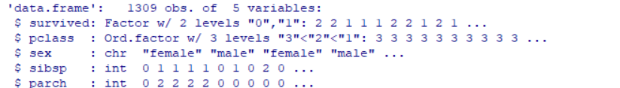

titanic$survived = factor(titanic$survived)
titanic$pclass = factor(titanic$pclass, order=TRUE, levels = c(3, 2, 1))
ggplot(titanic,aes(x = survived))+
geom_bar(width=0.5, fill = "coral") +
geom_text(stat='count', aes(label=stat(count)), vjust=-0.5) +
theme_classic()

train_test_split = function(data, fraction = 0.8, train = TRUE) {
total_rows = nrow(data)
train_rows = fraction * total_rows
sample = 1:train_rows
if (train == TRUE) {
return (data[sample, ])
} else {
return (data[-sample, ])
}
}
train <- train_test_split(titanic, 0.8, train = TRUE)
test <- train_test_split(titanic, 0.8, train = FALSE)
fit <- rpart(survived~., data = train, method ='class')
rpart.plot(fit, extra = 106)
predicted = predict(fit, test, type = 'class')
table = table(test$survived, predicted)
table
predicted
0 1
0 166 41
- 21 34
accuracy_Test <- sum(diag(table)) / sum(table)
print(paste('Accuracy for test', accuracy_Test))

OUTPUT

[1] "Accuracy for test 0.763358778625954"

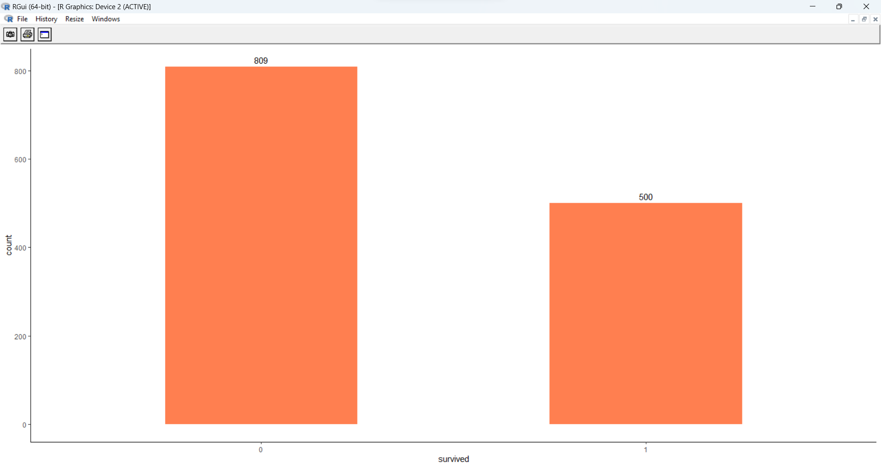
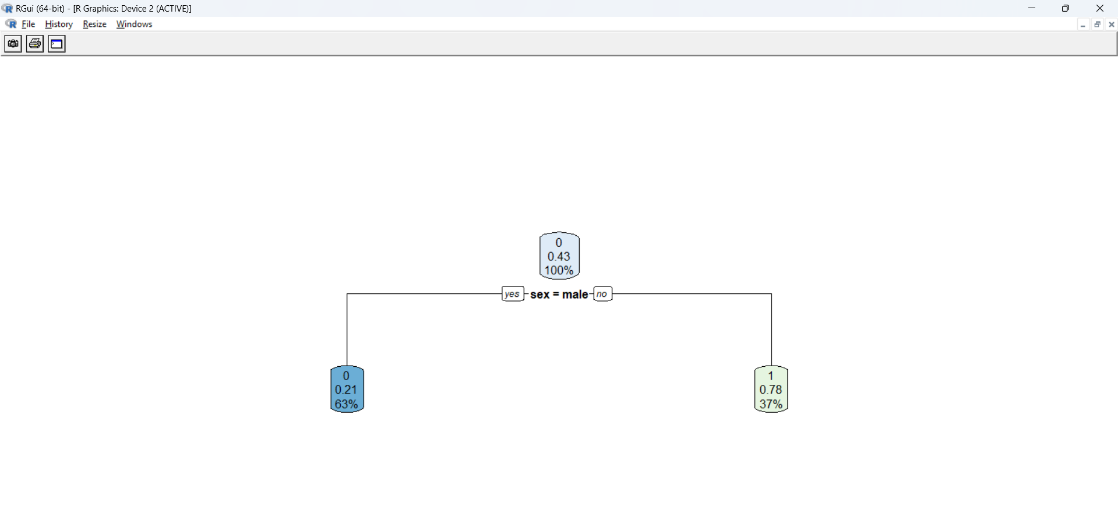

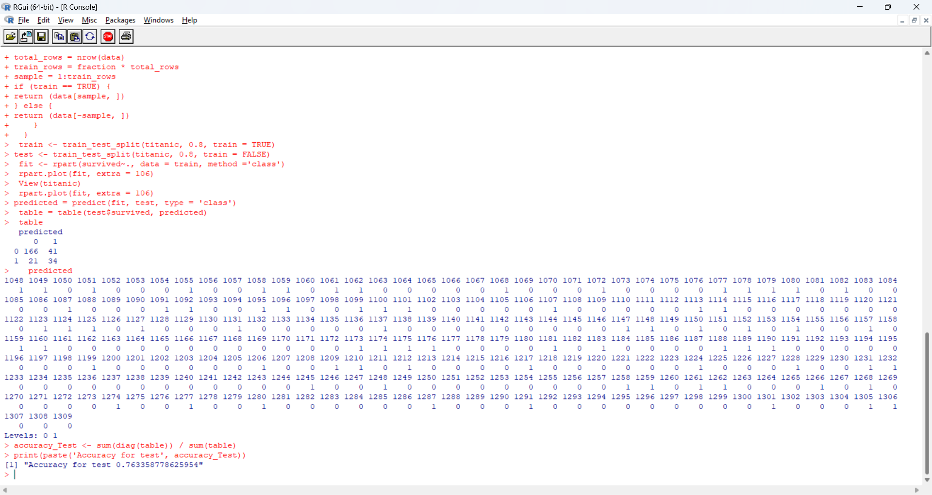

Ex. No:10 | Implementation of Titanic Survival Prediction using Naive Bayes Algorithm
Date: 05.03.2024

AIM
To show the implementation of Naive Bayes algorithm using titanic dataset.
PROCEDURE
Step 1: Load the dataset.
Step 2: Create train and test set.
- train <- train_test_split(titanic, 0.8, train = TRUE)
- test <- train_test_split(titanic, 0.8, train = FALSE)

Step 3: Build the model.
- Install Package e1071
- Load the package
- nb_model <- naiveBayes(survived ~ ., data = train)
Step 4: Make prediction.
nb_predict <- predict(nb_model, test)
Step 5: Measure performance evaluation by confusion matrix and calculate accuracy.
CODE
install.packages(“dplyr”)
library(dplyr)
install.packages(“caret”)
library(caret)
install.packages("e1071")
library("e1071")
install.packages(“ggplot2”)
library("ggplot2")
titanic<-read.csv("D:/Faculty/R Programming/titanic_data.csv")
head(titanic)
tail(titanic)
titanic=select(titanic,survived,pclass,sex,sibsp,parch)
titanic=na.omit(titanic)
str(titanic)
'data.frame': 1309 obs. of 5 variables:
$ survived: int 1 1 0 0 0 1 1 0 1 0 ...
$ pclass : int 1 1 1 1 1 1 1 1 1 1 ...
$ sex : chr "female" "male" "female" "male" ...
$ sibsp : int 0 1 1 1 1 0 1 0 2 0 ...
$ parch : int 0 2 2 2 2 0 0 0 0 0 ...

titanic$survived = factor(titanic$survived)
titanic$pclass = factor(titanic$pclass, order=TRUE,levels = c(3, 2, 1))
ggplot(titanic,aes(x = survived))+ geom_bar(width=0.5, fill = "coral") + geom_text(stat='count', aes(label=stat(count)), vjust=-0.5) + theme_classic()
train_test_split = function(data, fraction = 0.8, train = TRUE)
+ {
+ total_rows = nrow(data)
+ train_rows = fraction * total_rows
+ sample = 1:train_rows
+ if (train == TRUE) {
+ return (data[sample, ])
+ } else {
+ return (data[-sample, ])
+ }
+ }
train <- train_test_split(titanic, 0.8, train = TRUE)
test <- train_test_split(titanic, 0.8, train = FALSE)
nb_model = naiveBayes(survived ~., data=train)
nb_predict = predict(nb_model,test)
table_mat = table(nb_predict, test$survived)
table_mat

nb_predict 0 1
0 173 21
- 34 34
nb_accuracy = sum(diag(table_mat)) / sum(table_mat)
paste("The accuracy is : ", nb_accuracy)

OUTPUT

[1] "The accuracy is : 0.790076335877863"

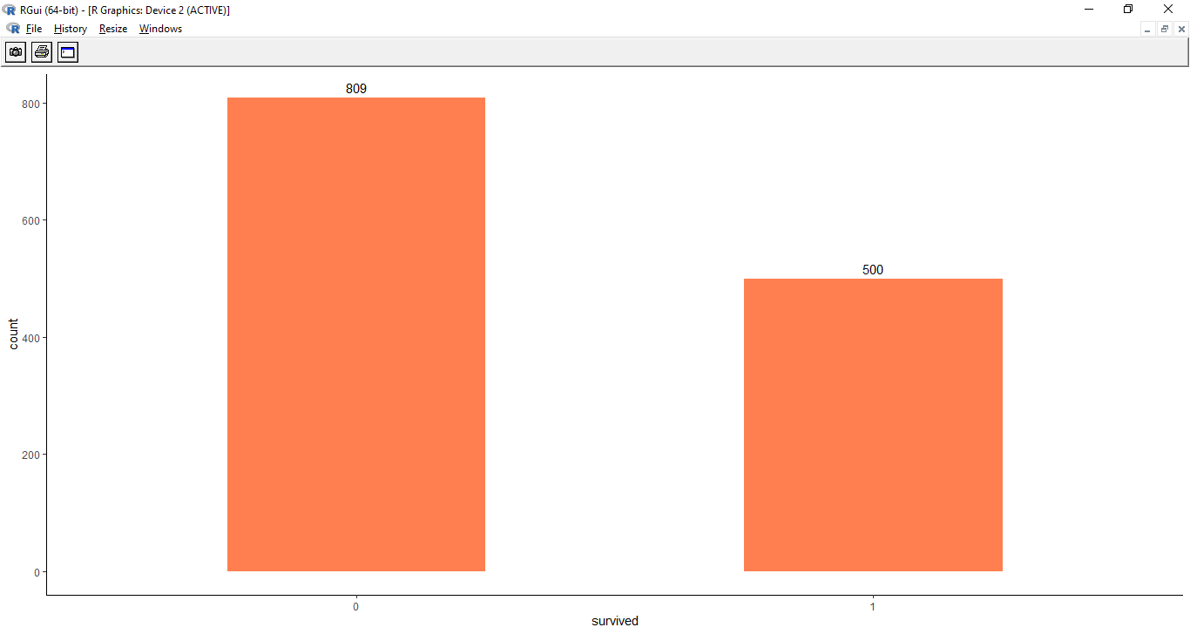

Ex. No:11 | Implementation of K Nearest Neighbor using Iris dataset
Date: 07.03.2024 | Implementation of K Nearest Neighbor using Iris dataset

AIM
To show the Implementation of KNN using iris dataset.
PROCEDURE
Step 1: Load the dataset
Step 2: Install the e1071, caTools, and class packages
Step 3: Split the data into train and test sets
- split <- sample.split(iris, SplitRatio = 0.7)
- train_cl <- subset(iris, split == "TRUE")
- test_cl <- subset(iris, split == "FALSE")

Step 4: Build the KNN Model
classifier_knn <- knn(train = train_scale, test = test_scale, cl = train_cl$Species, k = 1)
Step 5: Generate a confusion matrix to evaluate performance of the model on the test set.
Step 6: Calculate out of Sample error for the model.
Step 7: Evaluate Different Values of K (3, 5, 7, 15, 19) for accuracy.
Step 8: Use ggplot2 to create a line plot showing model accuracy for different values of k

CODE

iris<-read.csv("D:/R programming/iris_dataset.csv")
# Loading data
data(iris)
head(iris)
tail(iris)
# Structure
str(iris)
# Installing Packages
install.packages("e1071")
install.packages("caTools")
install.packages("class")
# Loading package
library(e1071)
library(caTools)
library(class)

# Splitting data into train and test data
split <- sample.split(iris, SplitRatio = 0.7)
train_cl <- subset(iris, split == "TRUE")
test_cl <- subset(iris, split == "FALSE")
# Feature Scaling
train_scale <- scale(train_cl[, 1:4])
test_scale <- scale(test_cl[, 1:4])
head(train_scale)
head(test_scale)

# Fitting KNN Model to training dataset
classifier_knn <- knn(train = train_scale,
test = test_scale,
cl = train_cl$Species,
k = 1)
classifier_knn
# Confusion Matrix
cm <- table(test_cl$Species, classifier_knn)
cm

# Model Evaluation - Choosing K
# Calculate out of Sample error
misClassError <- mean(classifier_knn != test_cl$Species)
print(paste('Accuracy =', 1-misClassError))

# K = 3
classifier_knn <- knn(train = train_scale,
test = test_scale,
cl = train_cl$Species,
k = 3)
misClassError <- mean(classifier_knn != test_cl$Species)
print(paste('Accuracy =', 1-misClassError))

# K = 5
classifier_knn <- knn(train = train_scale,
test = test_scale,
cl = train_cl$Species,
k = 5)
misClassError <- mean(classifier_knn != test_cl$Species)
print(paste('Accuracy =', 1-misClassError))

# K = 7
classifier_knn <- knn(train = train_scale,
test = test_scale,
cl = train_cl$Species,
k = 7)
misClassError <- mean(classifier_knn != test_cl$Species)
print(paste('Accuracy =', 1-misClassError))

# K = 15
classifier_knn <- knn(train = train_scale,
test = test_scale,
cl = train_cl$Species,
k = 15)
misClassError <- mean(classifier_knn != test_cl$Species)
print(paste('Accuracy =', 1-misClassError))

# K = 19
classifier_knn <- knn(train = train_scale,
test = test_scale,
cl = train_cl$Species,
k = 19)
misClassError <- mean(classifier_knn != test_cl$Species)
print(paste('Accuracy =', 1-misClassError))

library(ggplot2)

# Data preparation
k_values <- c(1, 3, 5, 7, 15, 19)

# Calculate accuracy for each k value
accuracy_values <- sapply(k_values, function(k) {
classifier_knn <- knn(train = train_scale,
test = test_scale,
cl = train_cl$Species,
k = k)
1 - mean(classifier_knn != test_cl$Species)
})

# Create a data frame for plotting
accuracy_data <- data.frame(K = k_values, Accuracy = accuracy_values)

# Plotting
ggplot(accuracy_data, aes(x = K, y = Accuracy)) +
geom_line(color = "lightblue", size = 1) +
geom_point(color = "lightgreen", size = 3) +
labs(title = "Model Accuracy for Different K Values",
x = "Number of Neighbors (K)",
y = "Accuracy") +
theme_minimal()

OUTPUT

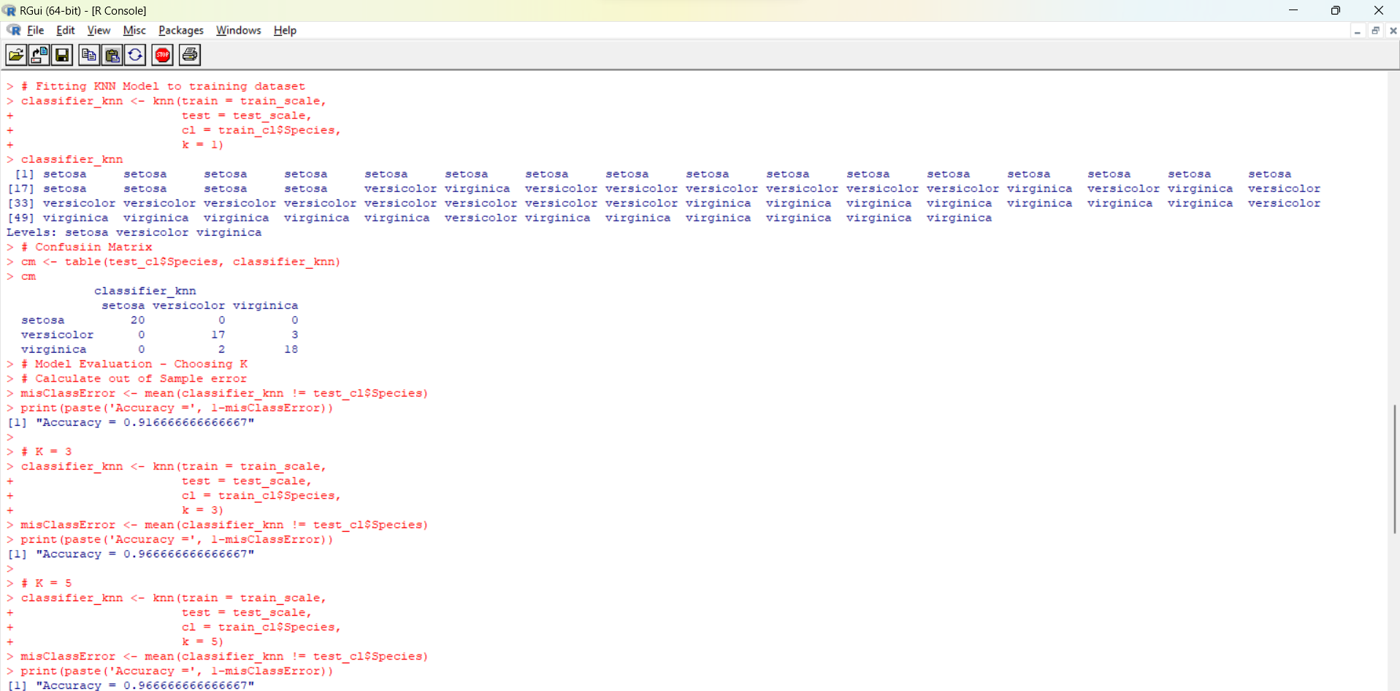

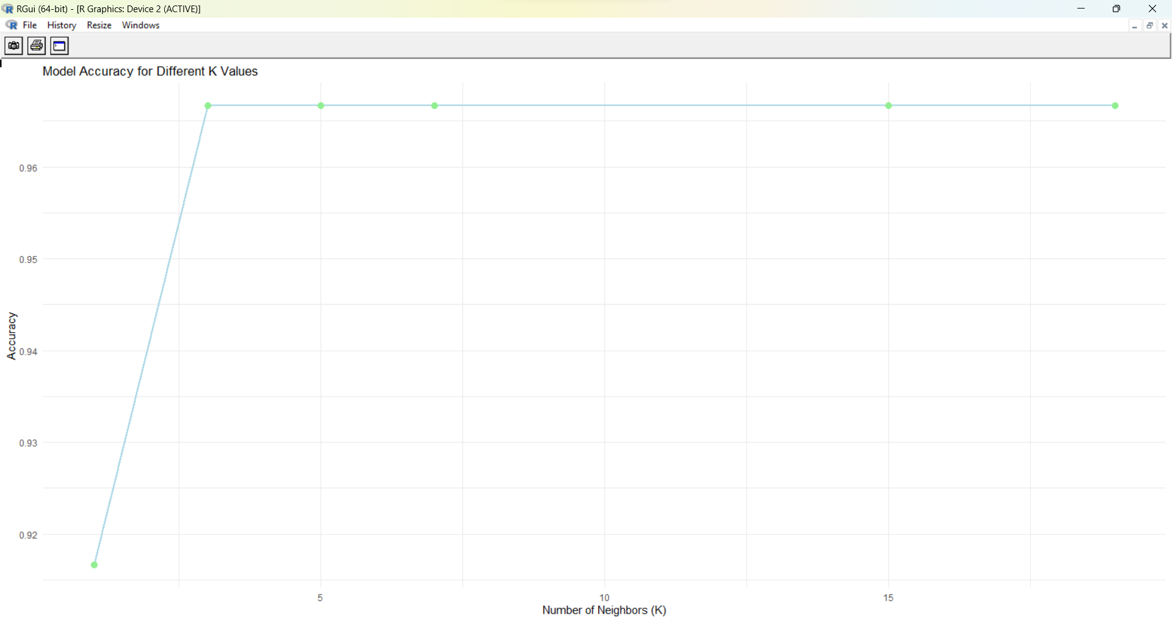

Ex. No:12 | Implementation of Random Forest Algorithm using Iris Dataset
Date: 19.03.2024 | Implementation of Random Forest Algorithm using Iris Dataset

AIM
To show the Implementation of Random Forest using iris dataset.
PROCEDURE
Step 1: Load the dataset
Step 2: Create train and test set.
- split <- sample.split(iris, SplitRatio = 0.7)
- train <- subset(iris, split == "TRUE")
- test <- subset(iris, split == "FALSE")
Step 3: Build the model.
i. Set control parameters for model training
ii. Set seed for reproducibility
iii. Train the Random Forest model
rf <- train(Species ~ ., data=train, method="rf", metric=metric, tuneLength=15, trControl=control)
Step 4: Use Grid Search for Hyperparameter Tuning
tunegrid <- expand.grid(.mtry=c(1:4))
Step 5: Plot the grid search.

CODE

iris<-read.csv("D:/R programming/iris_dataset.csv")
# Loading data
data(iris)
head(iris)
tail(iris)
# Structure
str(iris)

# Installing package
install.packages(“caTools”)
library(“caTools”)
install.packages(“randomForest”)
library(“randomForest”)
install.packages(“caret”)
library("caret")
# Splitting data in train and test data
split <- sample.split(iris, SplitRatio = 0.7)
split
[1] FALSE TRUE TRUE TRUE FALSE

train <- subset(iris, split == "TRUE")
test <- subset(iris, split == "FALSE")
# Fitting Random Forest to the train dataset
control <- trainControl(method="repeatedcv", number=10, repeats=3)
seed <- 7
metric <- "Accuracy"
set.seed(seed)
rf <- train(Species~., data=iris, method="rf", metric=metric, tuneLength=15, trControl=control)
print(rf)
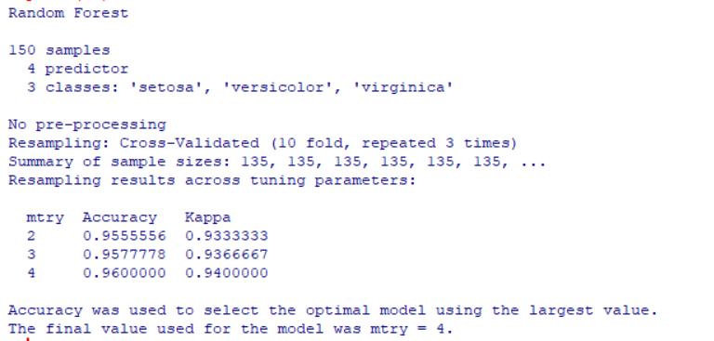

# Grid Search
tunegrid <- expand.grid(.mtry=c(1:4))
rf_gridsearch <- train(Species~., data=iris, method="rf", metric=metric, tuneGrid=tunegrid, trControl=control)
print(rf_gridsearch)

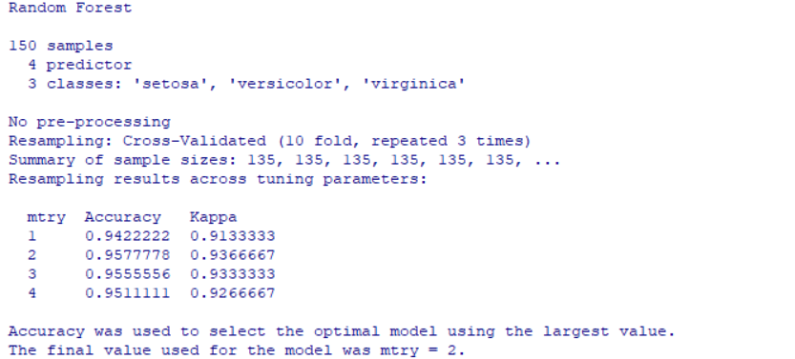

plot(rf_gridsearch)

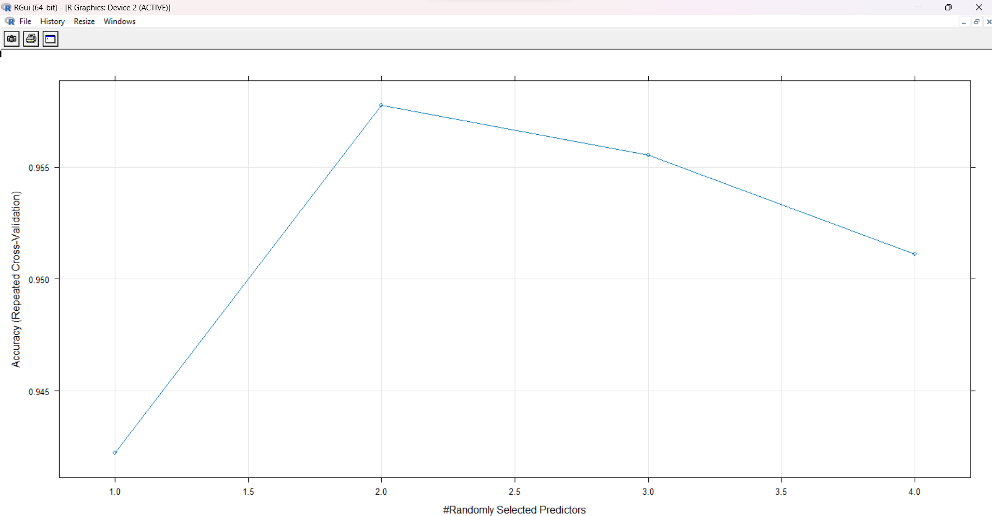

Ex. No:13 | Implementation of K Means Clustering
Date: 26.03.2024 | Implementation of K Means Clustering

AIM
To show the implementation of K Means Algorithm using USArrest Dataset
PROCEDURE
Step 1: Load the dataset
Step 2: Choose the number K clusters.
Step 3: Select at random K points
Step 4: Assign each data point to closest centroid that forms K clusters
Step 5: Compute and place the new centroid of each centroid
Step 6: Reassign each data point to new cluster.
CODE

mydata<-read.csv("D:/R programming/USArrests.csv")
head(mydata)
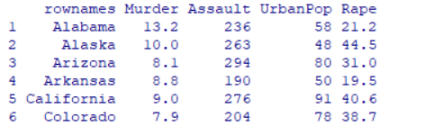
tail(mydata)
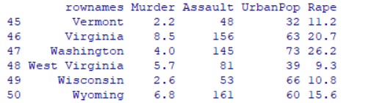
mydata$rownames

install.packages("factoextra")
library(factoextra)
#Scales/standardizes the data
USdata <- scale(mydata[,-1])
head(USdata)
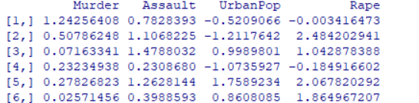

#K-means clustering with 2, 3, 4 and 5 centers
kmeans.cluster_2 <- kmeans(USdata, centers = 2, nstart = 20)
kmeans.cluster_2

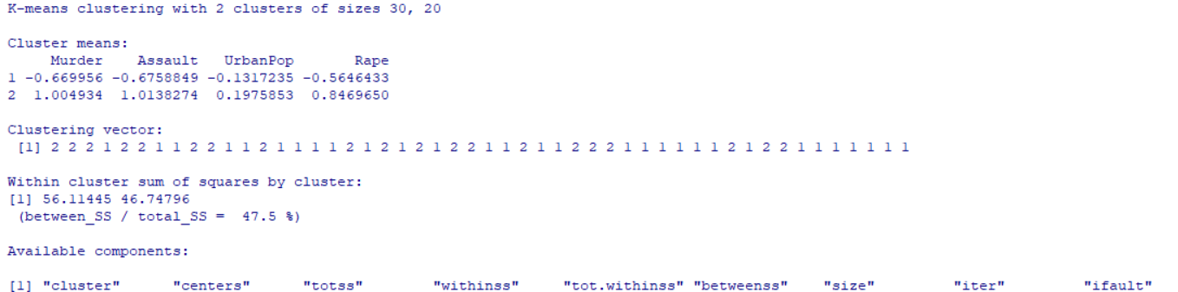

kmeans.cluster_3 <- kmeans(USdata, centers = 3, nstart = 20)
kmeans.cluster_3
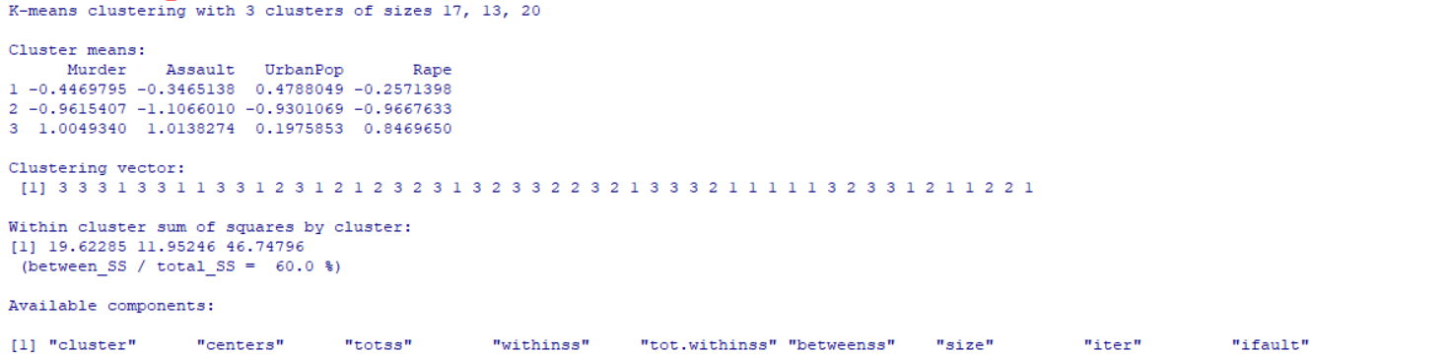

kmeans.cluster_4 <- kmeans(USdata, centers = 4, nstart = 20)
kmeans.cluster_4
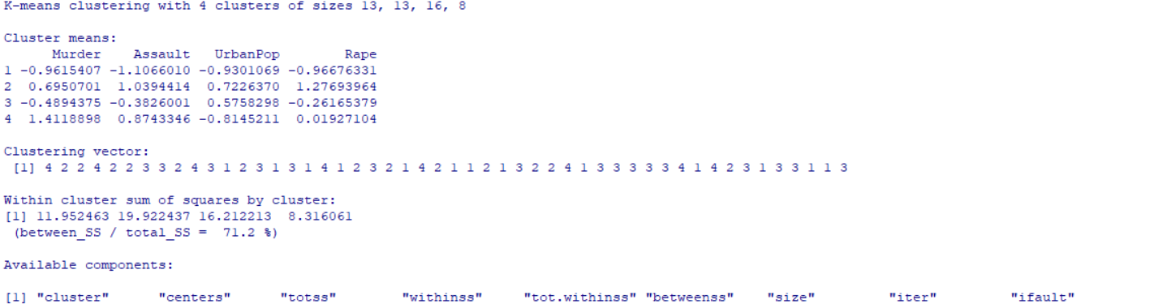

kmeans.cluster_2$cluster
[1] 2 2 2 1 2 2 1 1 2 2 1 1 2 1 1 1 1 2 1 2 1 2 1 2 2 1 1 2 1 1 2 2 2 1 1 1 1 1 1 2 1 2 2 1 1 1 1 1 1 1
kmeans.cluster_3$cluster
[1] 3 3 3 1 3 3 1 1 3 3 1 2 3 1 2 1 2 3 2 3 1 3 2 3 3 2 2 3 2 1 3 3 3 2 1 1 1 1 1 3 2 3 3 1 2 1 1 2 2 1
kmeans.cluster_4$cluster
[1] 4 2 2 4 2 2 3 3 2 4 3 1 2 3 1 3 1 4 1 2 3 2 1 4 2 1 1 2 1 3 2 2 4 1 3 3 3 3 3 4 1 4 2 3 1 3 3 1 1 3
kmeans.cluster_5$cluster
[1] 4 1 1 5 1 1 2 2 1 4 2 3 1 5 3 5 5 4 3 1 2 1 3 4 5 5 5 1 3 2 1 1 4 3 2 5 5 2 2 4 3 4 1 2 3 5 2 3 3 5

fviz_cluster(kmeans.cluster_2, data = USdata)
fviz_cluster(kmeans.cluster_3, data = USdata)
fviz_cluster(kmeans.cluster_4, data = USdata)
fviz_cluster(kmeans.cluster_5, data = USdata)

#Creates a plot showing the silhouette and elbow methods in determining the amount of optimal centers.
fviz_nbclust(USdata, FUN = kmeans, method = "silhouette")

OUTPUT

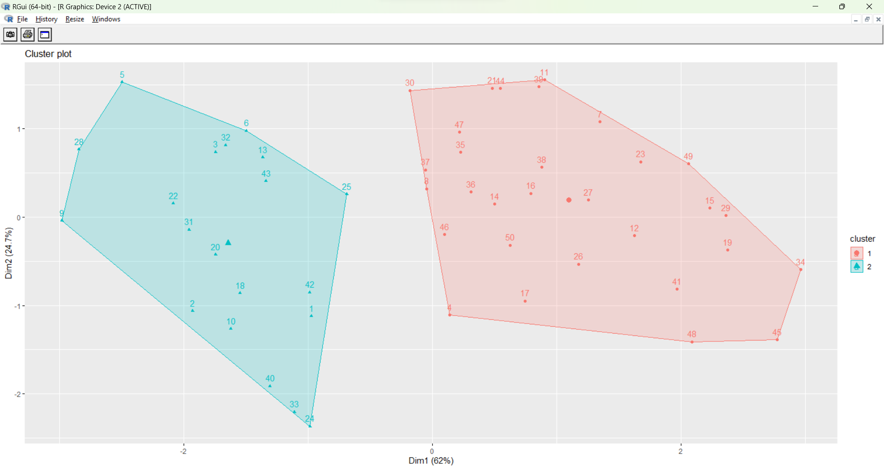

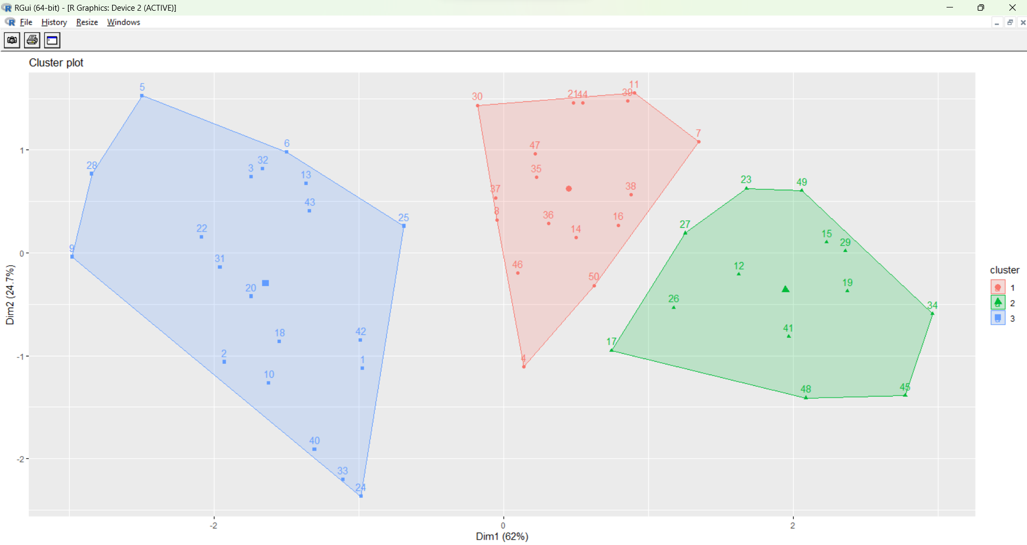
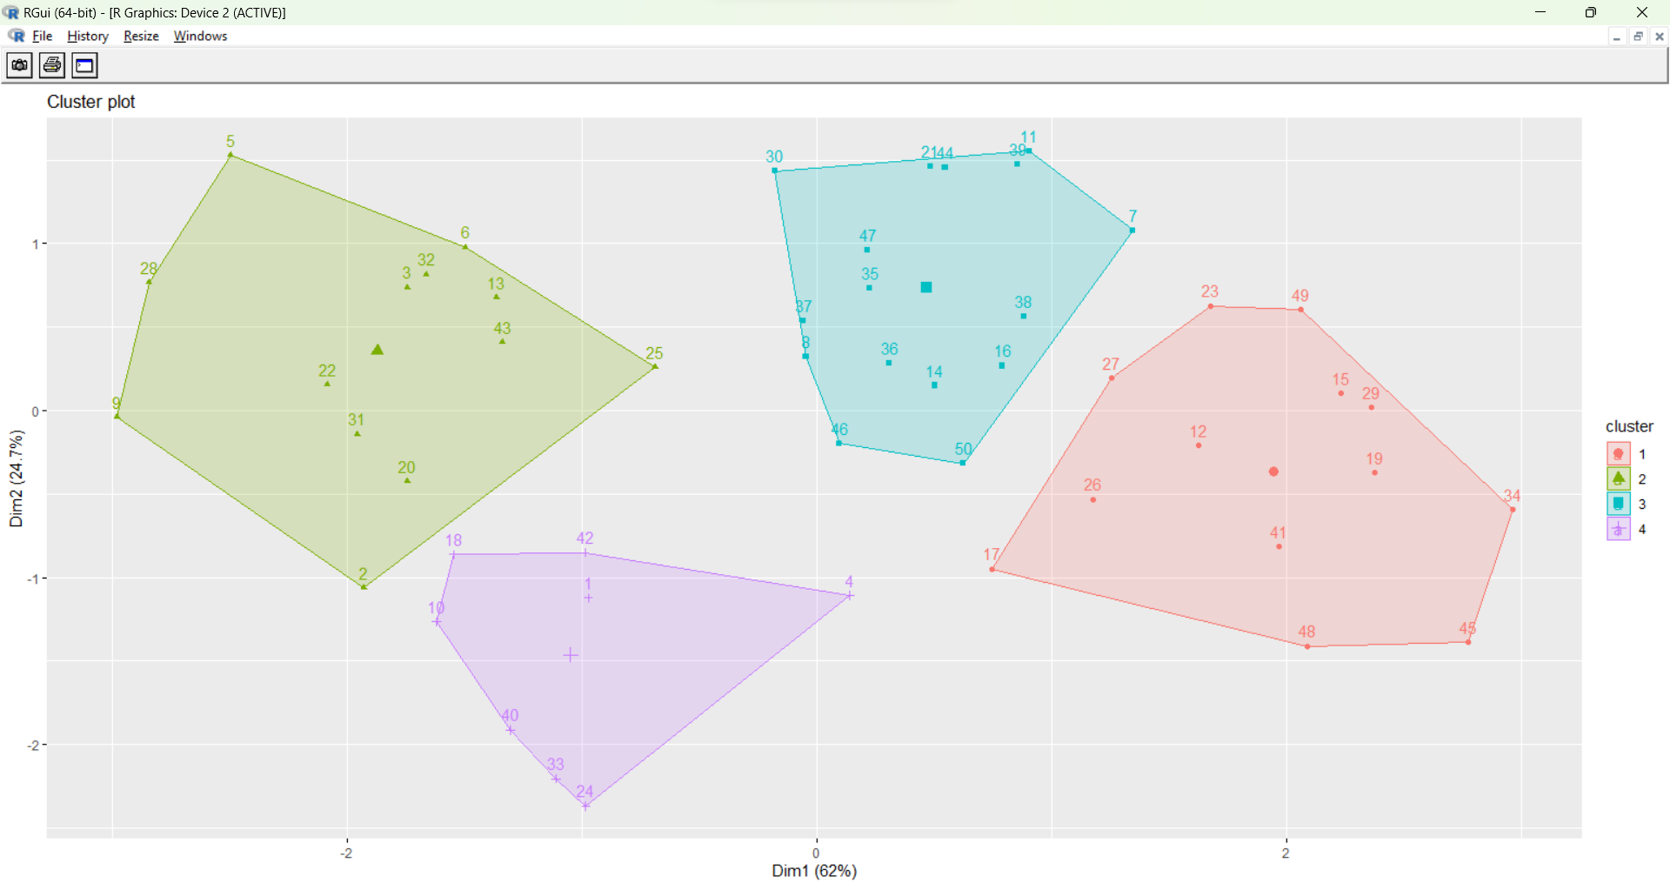

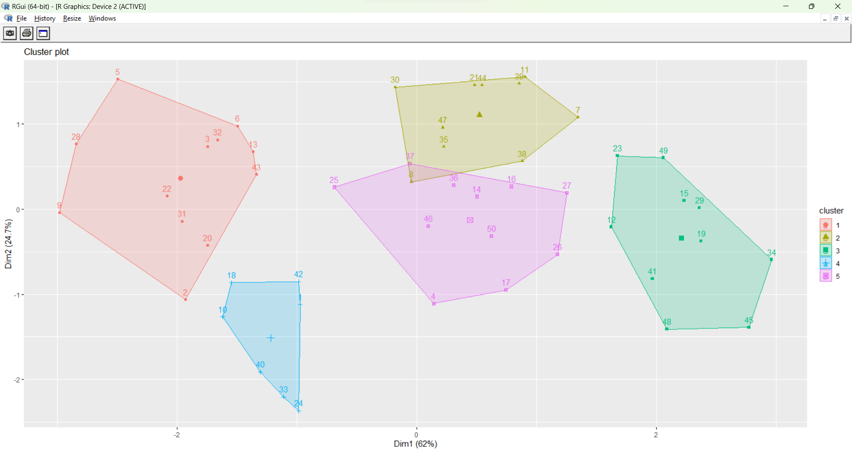
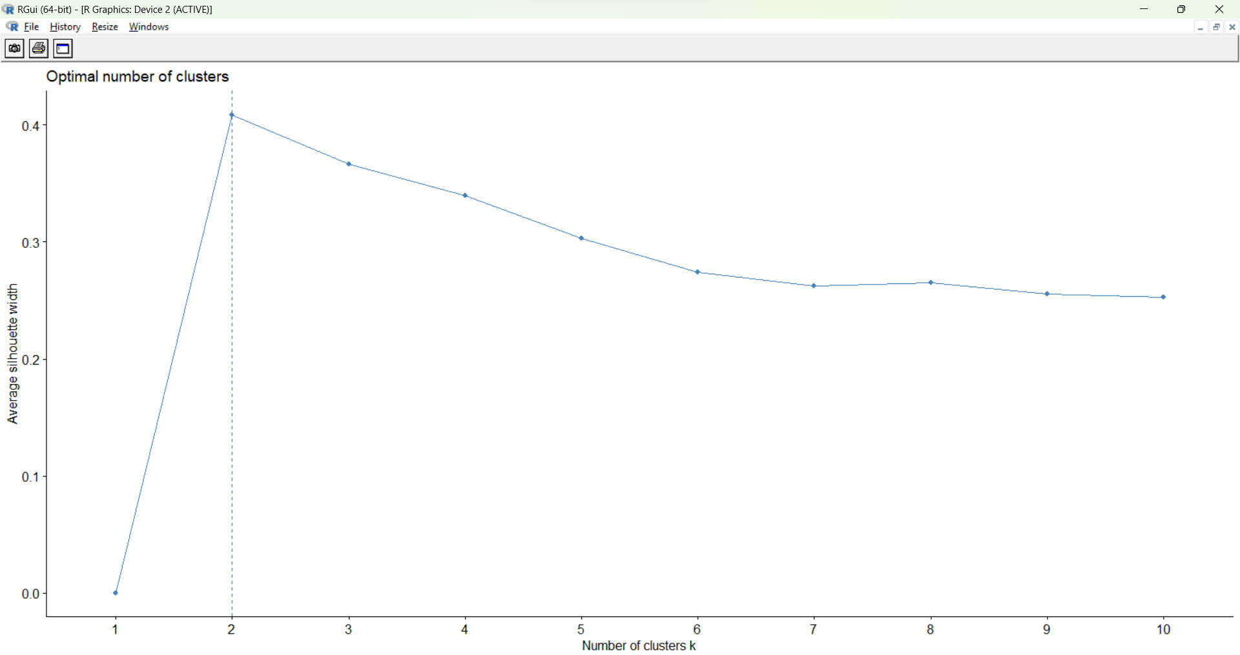

Ex. No:14 | Data Visualization in R
Date: 28.03.2024 | Data Visualization in R

AIM
To illustrate the concept of data visualization in R using air quality dataset.

PROCEDURE

Step 1: Horizontal bar plot displays categorical data using horizontal bars, with the length of each bar representing the frequency or value of the corresponding category.
Step 2: Vertical Bar Plot represents categorical data using vertical bars, with the height of each bar indicating the frequency or value of the corresponding category.
Step 3: Histogram illustrates the distribution of numerical data by dividing it into bins and displaying the frequency of observations within each bin as vertical bars.
Step 4: Box plot represents average wind speed
Step 5: Multiple Box plots, each represents an Air Quality Parameter
Step 6: Scatter plot illustrates Ozone Concentration per month
Step 7: Visualize data patterns using heatmap

Step 8: Prepare variables, add Titles and Labeling Axes and plot the 3D surface.

CODE

mydata<-read.csv("D:/R programming/airquality.csv")
str(mydata)
# Horizontal Bar Plot for Ozone concentration in air
barplot(airquality$Ozone,
main = 'Ozone Concenteration in air',
xlab = 'ozone levels', horiz = TRUE)

OUTPUT

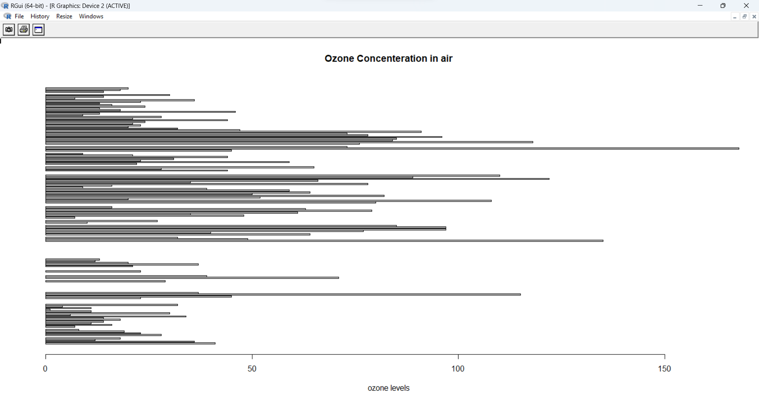

# Vertical Bar Plot for Ozone concentration in air
barplot(airquality$Ozone, main = 'Ozone Concenteration in air',
xlab = 'ozone levels', col ='blue', horiz = FALSE)

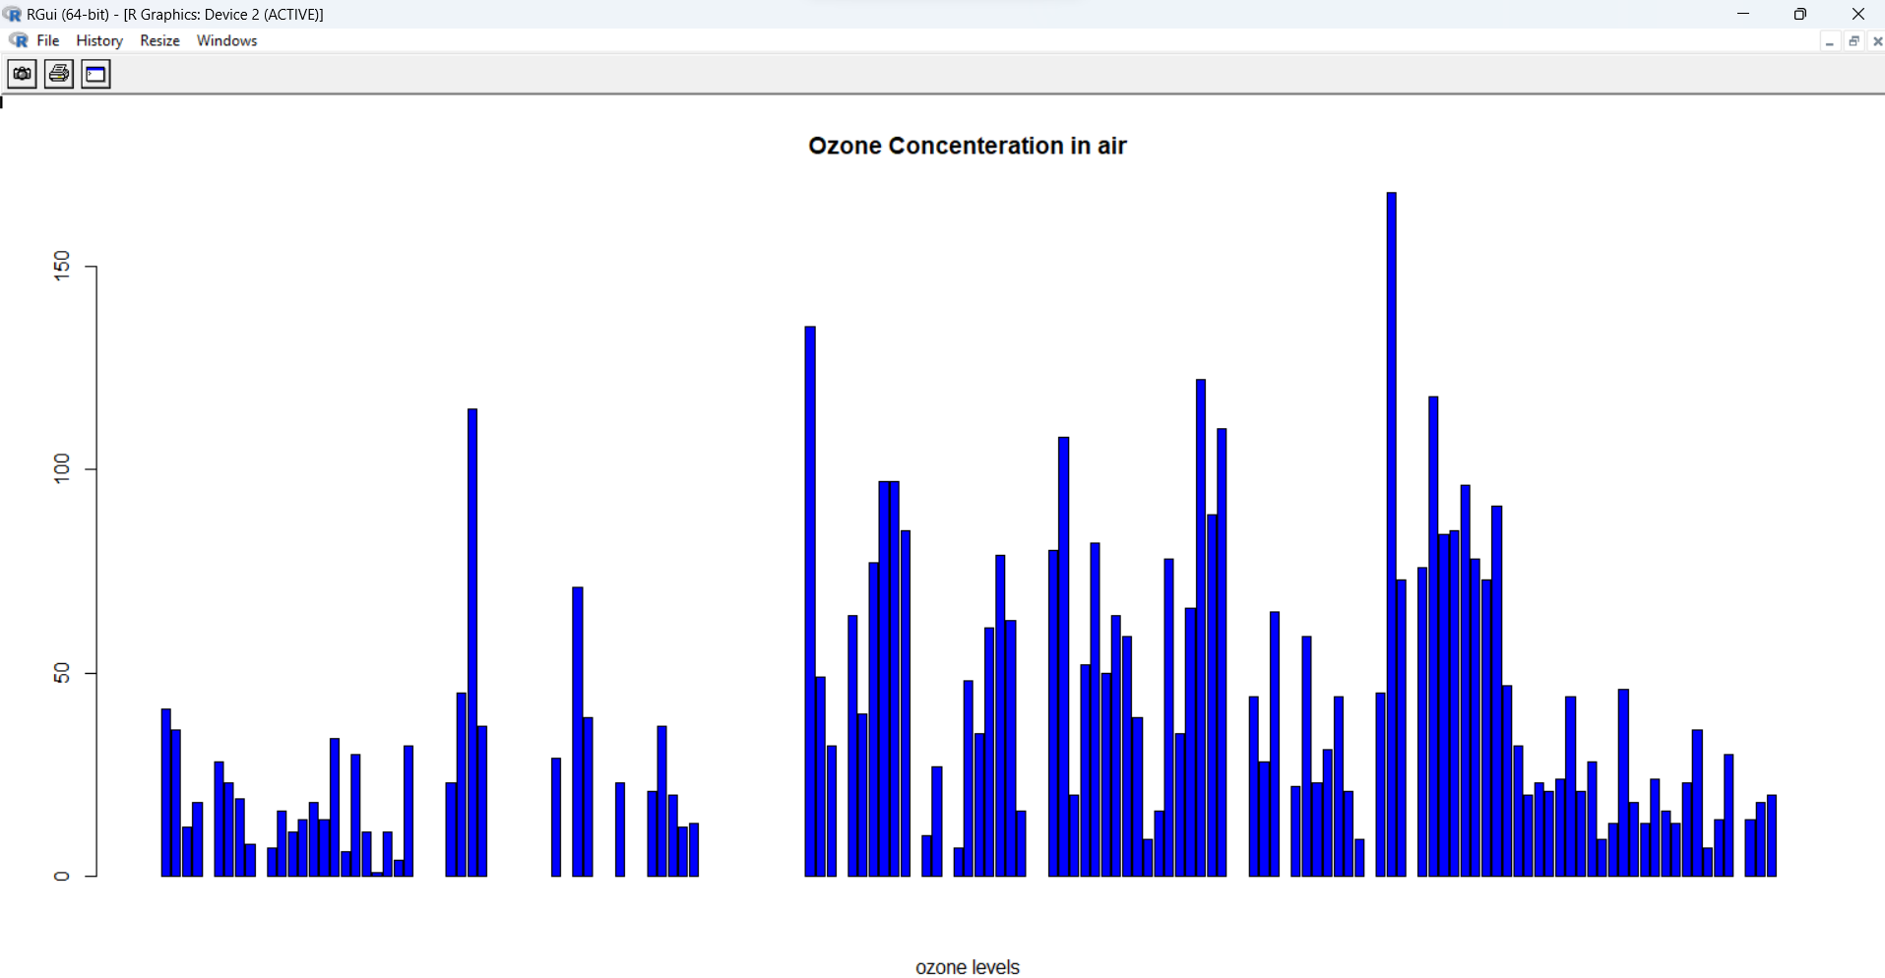

# Histogram for Maximum Daily Temperature
data(airquality)
hist(airquality$Temp, main ="La Guardia Airport's\
Maximum Temperature(Daily)",
xlab ="Temperature(Fahrenheit)",
xlim = c(50, 125), col ="yellow",
freq = TRUE)

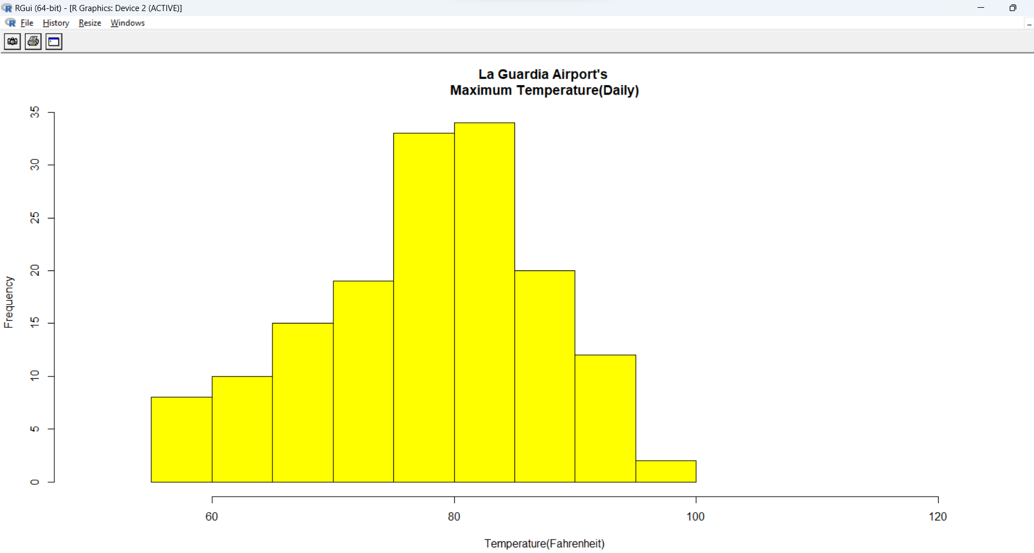
# Box plot for average wind speed
data(airquality)
boxplot(airquality$Wind, main = "Average wind speed\
at La Guardia Airport",
xlab = "Miles per hour", ylab = "Wind",
col = "orange", border = "brown",
horizontal = TRUE, notch = TRUE)

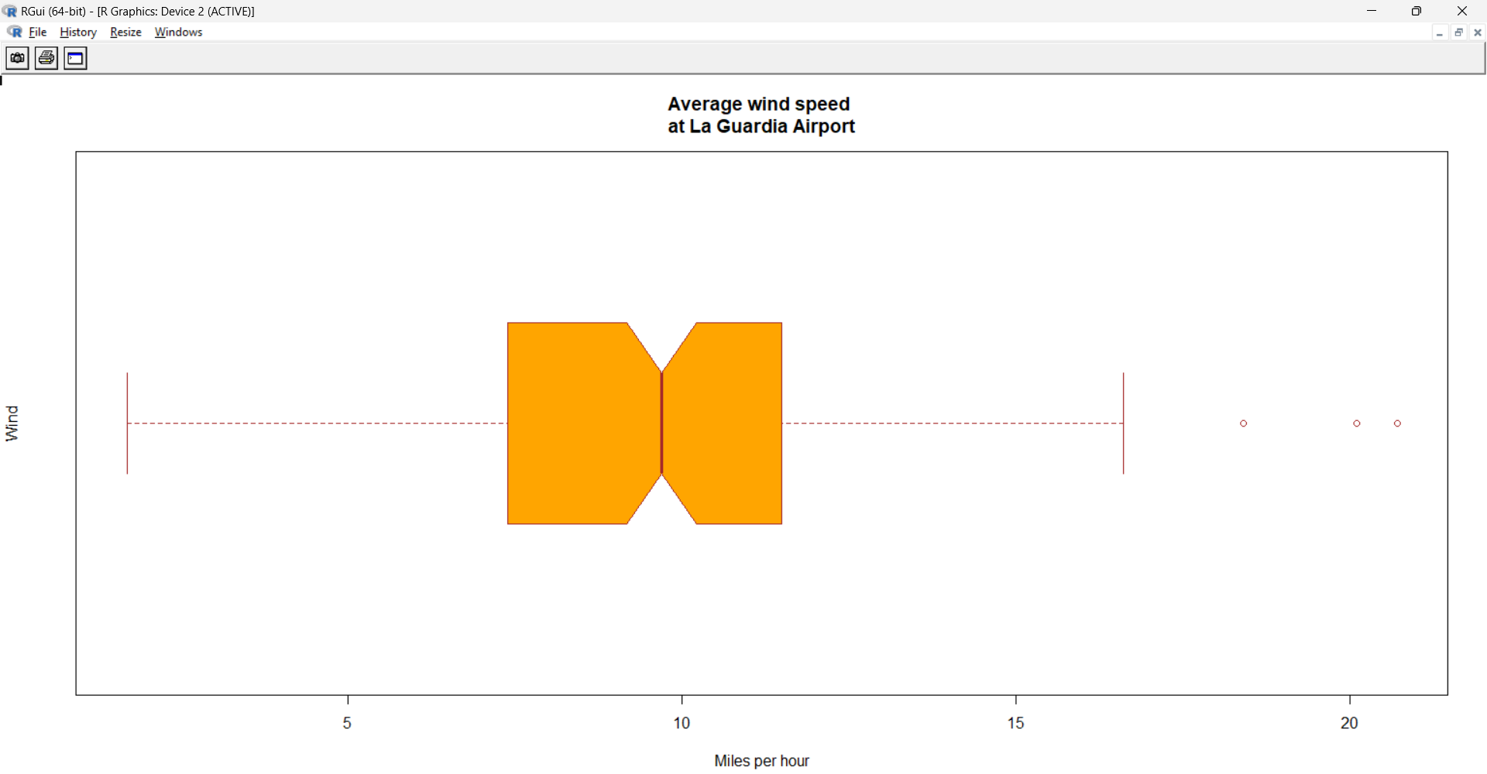
# Multiple Box plots, each representing an Air Quality Parameter
boxplot(airquality[, 0:4],
main ='Box Plots for Air Quality Parameters')

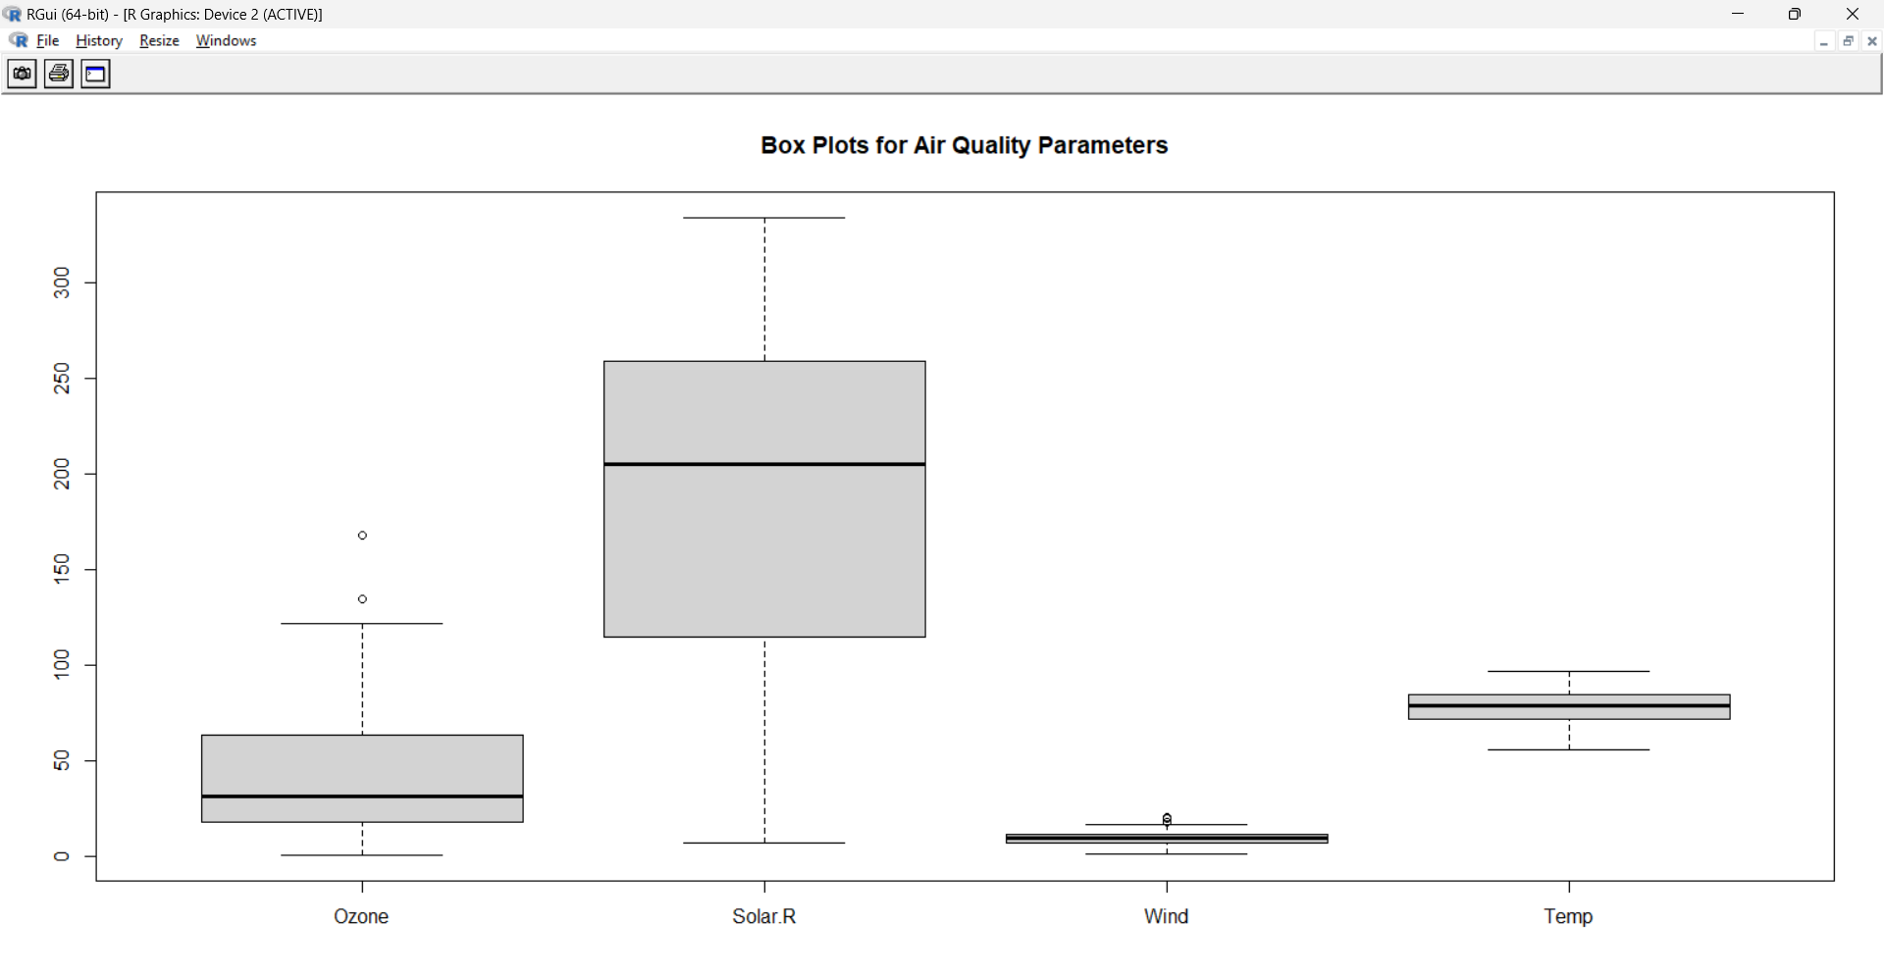

# Scatter plot for Ozone Concentration per month
data(airquality)
plot(airquality$Ozone, airquality$Month,
main ="Scatterplot Example",
xlab ="Ozone Concentration in parts per billion",
ylab =" Month of observation ", pch = 19)

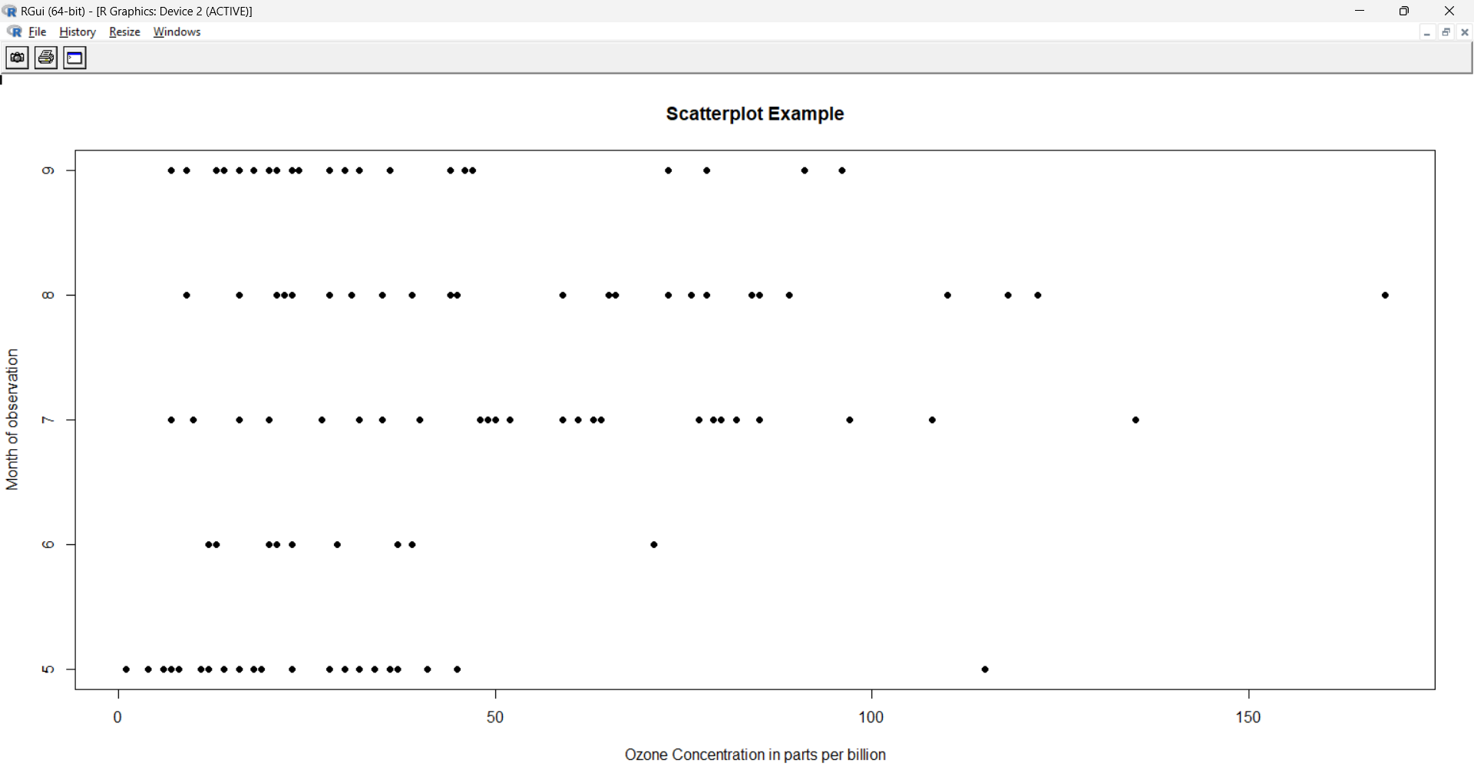
# Set seed for reproducibility
# set.seed(110)
# Create example data
data <- matrix(rnorm(50, 0, 5), nrow = 5, ncol = 5)
# Column names
colnames(data) <- paste0("col", 1:5)
rownames(data) <- paste0("row", 1:5)
# Draw a heatmap
heatmap(data)

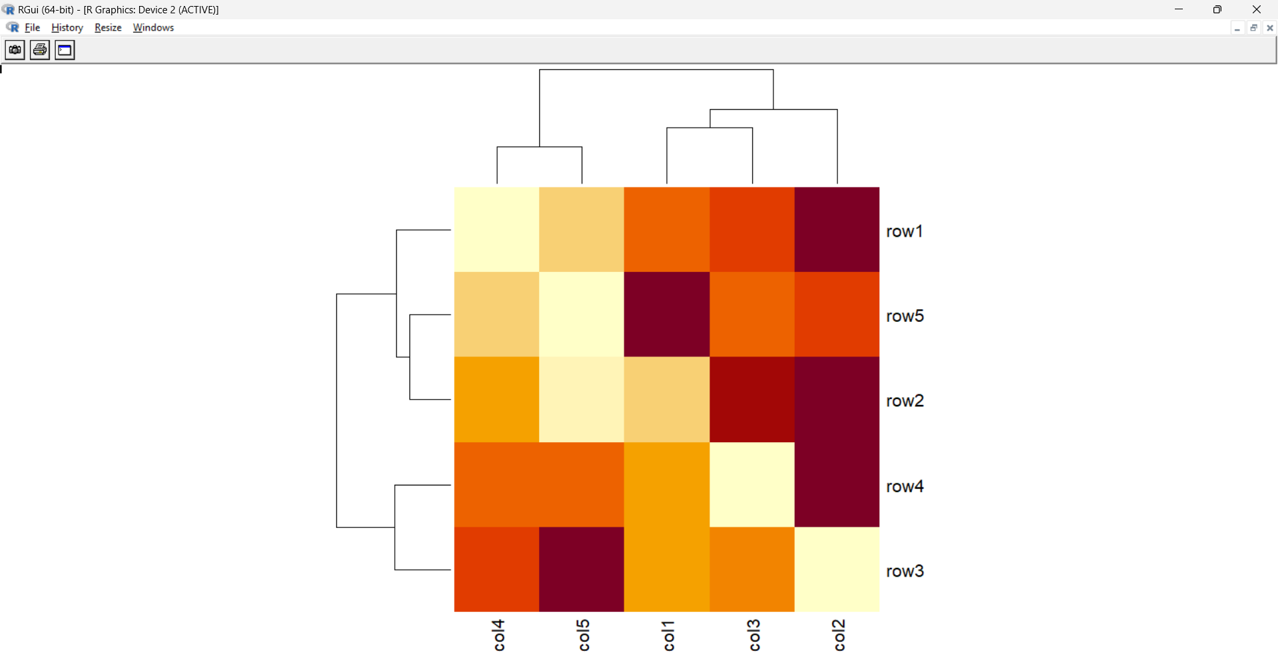

3D Graphs in R
# Adding Titles and Labeling Axes to Plot
cone <- function(x, y){
sqrt(x ^ 2 + y ^ 2)
}

# prepare variables.
x <- y <- seq(-1, 1, length = 30)
z <- outer(x, y, cone)
# plot the 3D surface
# Adding Titles and Labeling Axes to Plot
persp(x, y, z,
main="Perspective Plot of a Cone",
zlab = "Height",
theta = 30, phi = 15,
col = "orange", shade = 0.4)

